Questions:
- Is it okay to have ethernet port sticking out like that out of the board?
- Mounting of the board onto the inverter
- Is it okay that the through hole has an outline in the mechanical layer as well?

Routing
- Via size what should I use?
  - Pad diameter + annular rings
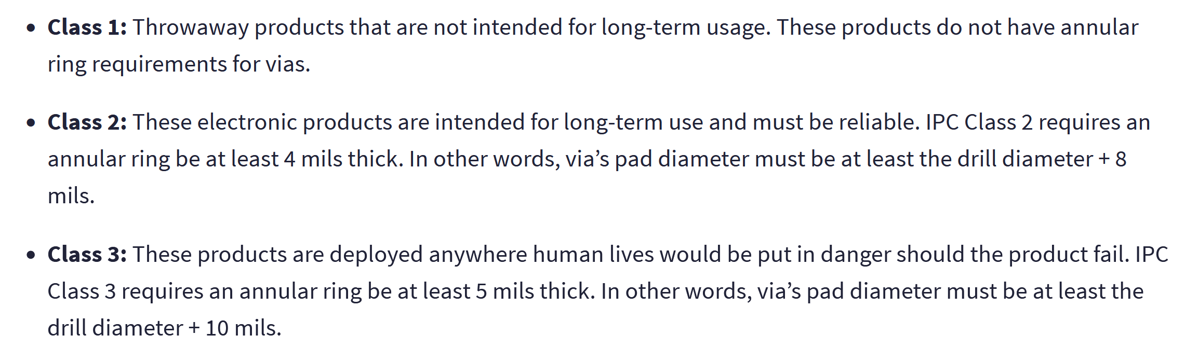

Confused as to how we will use the polygons
Top layer: GND -> why is the top layer also GND?
GND layer: GND
VCC layer: 5V
Bottom Layer: 3.3V
- All the components with 5V supply will be connected with Vias to the VCC layer
- All components with with 3.3V supply will be connected with Vias to the bottom layer
- Separate polygons for 2.5V and 1.7V needed?

- If I place a via to connect the top layer to the VCC layer (which is in the middle) is there anything I need to change in the properties or is it okay if I just assign the 5V net?
- How do I make sure each layer is connected to the correct voltage level?
  - Is it done if I connect the power to the layer?
  - And ofc also GND – how much should the GND be connected to a specific voltage level?

Questions:
- Mounting of the board onto the inverter
  - 3D printable model, easy mounting onto the inverter
- Is it okay that the through hole has an outline in the mechanical layer as well?
  - Can also use the schematic footprint in Kaans not necessary
Polygons
- Do we need polygons for 2.5V and 1.7V? (other than where the voltage reference is located?)
  - YES
  - We need to set vias at the op amps to get to 2.5V and 1.7V polygons which are on different levels
  - This means we have to connect the Voltage references to the op amps on another layer with a polygon right?
- Is there a reason why the top layer is also covered in a GND polygon?
  - For copper balance to prevent board from bending
- Vias: What size Via should I use?
  - Pad diameter + annular rings
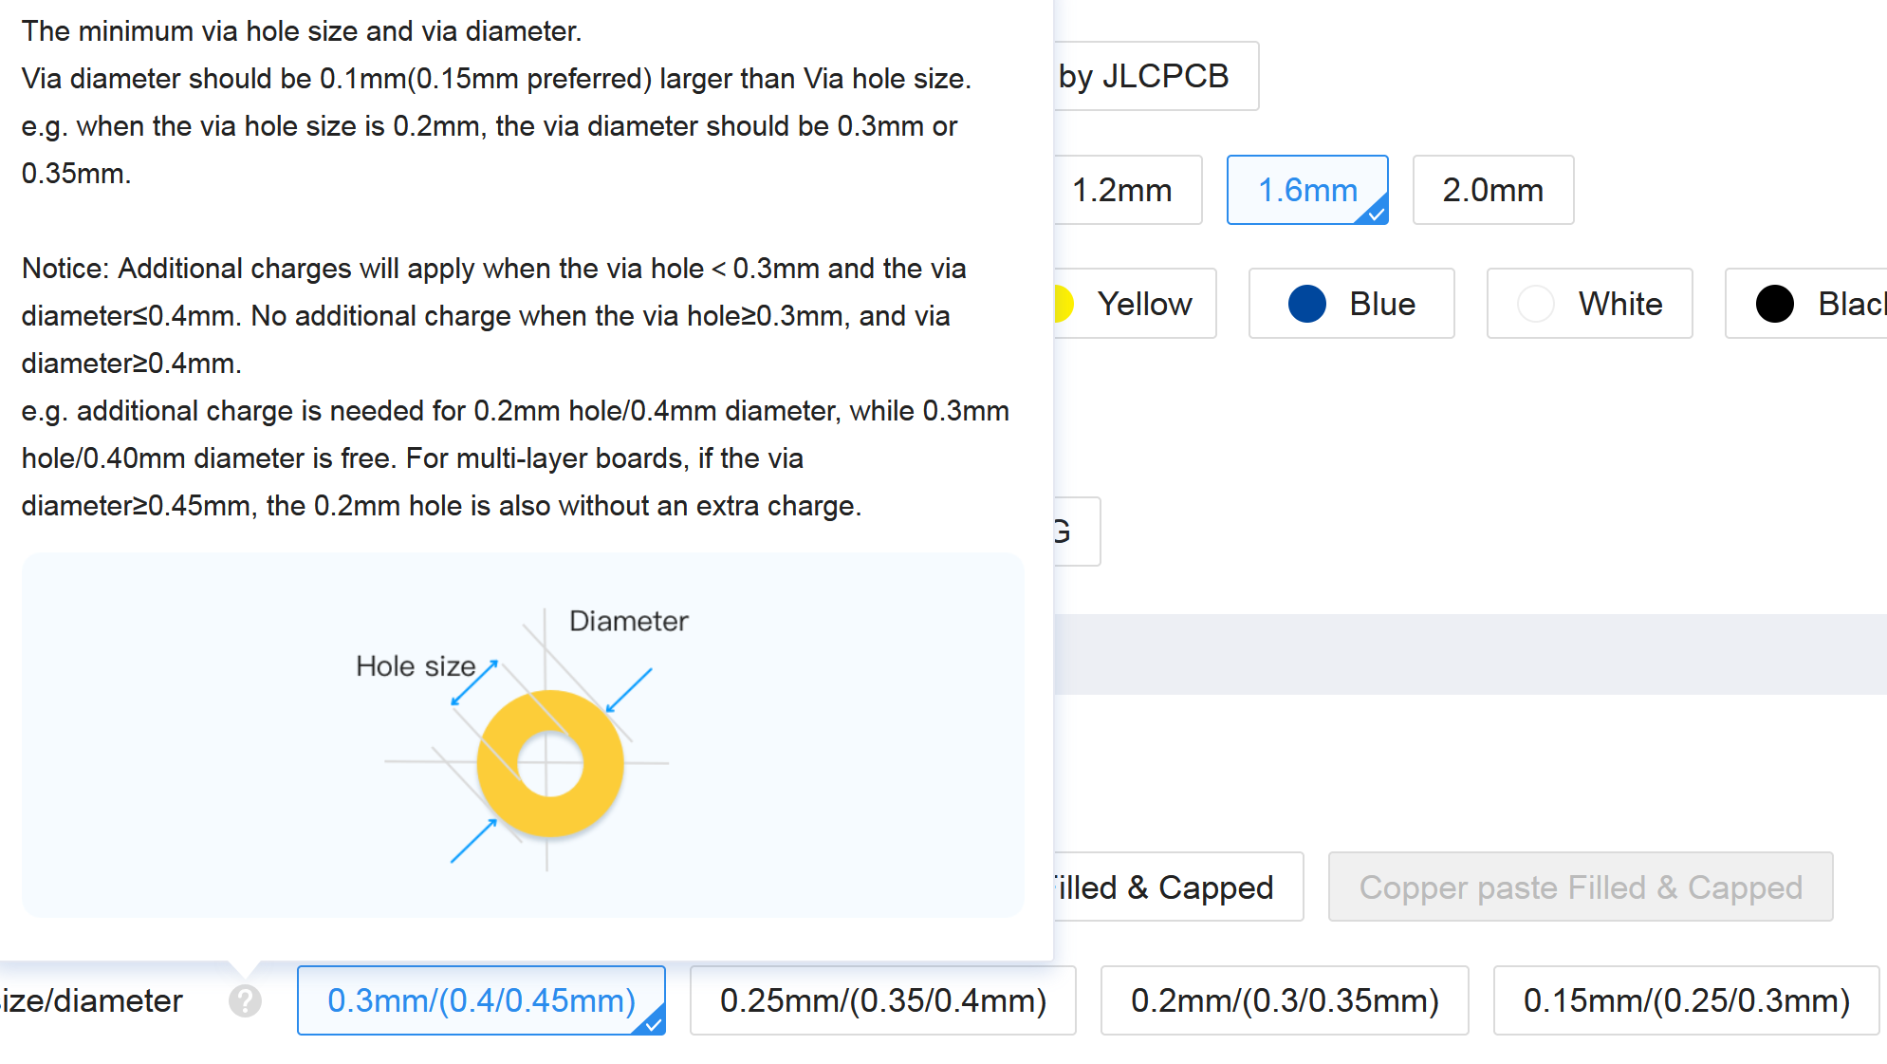
- If I place a via to connect the top layer to the VCC layer (which is in the middle) is there anything I need to change in the properties or is it okay if I just assign the 5V net?
- How do I make sure each layer is connected to the correct voltage level?
  - Is it done if I connect the power to the layer?
  - And ofc also GND – how much should the GND be connected to a specific voltage level?
- What happens if I put polygons on top of other polygons
  - There is no clearance being made here

Trace Width:
Power - 0.2mm
Signals – 0.15mm (min 0.102mm)
Current return pathway:
- Current concentration closest to flow path
- Therefore it is very bad to cut the GND layers because this means that when the current is returning to GND, it will have to take longer around pathways
  - Electromagnetic field changes – it becomes like an antenna
- Make sure ground planes are not cut through! And offer the shortest pathway in the direction current has flowed into the component in the first place

